**Full Stack Development with MERN**

**Database Design and Development Report**

| Date | 12-07-2024 |
| --- | --- |
| Team ID | SWTID1719925692 |
| Project Name | Bookstore |
| Maximum Marks |  |

**Project Title**: Book Corner

**Date**: 12-07-2024

**Prepared by**:

1.Shaneel Reddy

2 . Vinuthna

3 . Mahitha

4 . Allwin

**Objective**

This report describes the database design and implementation details along with the schema designs for collections in the mongodb database .

**Technologies Used**

* **Database Management System (DBMS):** MongoDB
* **Object-Document Mapper (ODM):** Mongoose

**Design the Database Schema**

The database schema is designed to accommodate the following entities and relationships:

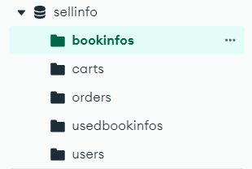

**1. bookinfos**

- Attributes: title , author ,category , imageurl ,description , price

**2. carts**

- Attributes: bookId , quantity

**3. orders**

- Attributes: userId , name , address , items , city , state , Phone

**4** . **usedbookinfos**

-attributes : title , author , category , description , imageUpload , quantity , Address , city , state ,zip

phone

**5** . **users**

- attributes : name , email , password

**Implement the Database using MongoDB**

The MongoDB database is implemented with the following collections and structures:

Database Name: sellinfo

1. Collection: bookinfos

- Schema:

{

_id: ObjectId,

title: String,

author: String,

imageUrl: String,

category: String,

description: String,

price :Number

}

2. Collection: carts

- Schema:

{

-id : ObjectId ,

bookId: ObjectId,

quantity : Number

}

3. Collection: orders

- Schema:

{

_id: ObjectId,

userId: ObjectId(references users),

items : object

Name :String ,

Address: String,

city: String,

state : String ,

Phone : Number

}

4. Collection: usedbookinfos

- Schema:

{

_id : ObjectId,

title: String,

author: String,

category: String,

description:String,

imageUpload: String,

quantity: Number,

Address : String,

city : String,

state : String,

zip : String,

Phone : String,

price : Number

}

5. Collection: users

- Schema :

{

-id : ObjectId,

name : String,

email : String,

password : String,

}

**Integration with Backend**

* Database connection: Give Screenshot of Database connection done using Mongoose

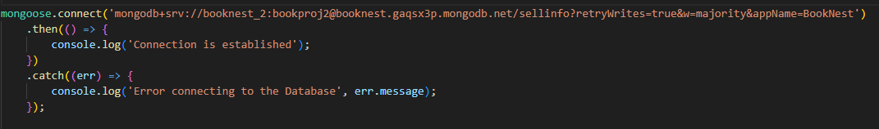

* The backend APIs interact with MongoDB using Mongoose ODM Key interactions include:
  + User Management: CRUD operations for user login and signup .
  + Cart Management : CRUD operations for adding , deleting and fetching the book.
  + Book Management : CRUD operations for posting ,deleting and fetching the books .
  + Order Management: CRUD operations for maintaining the orders of the users.